MARKING KEY
0000.doc

STAGE 2 COMPUTER SCIENCE EXAM MARKING GUIDE

SECTION 1—WRITTEN RESPONSE

Question 1

(a) Explain the difference between primary and secondary storage.

Description | Mark
Primary—main memory is part of the computer that holds program instructions and data | 1
Secondary—permanent storage devices that store larger amounts of data, instructions, and information more permanently than allowed with main memory | 1

(b) Give an example of each.
Description | Mark
Primary—RAM, ROM, | ½
Secondary—Hard disk, Floppy disk, USB disk, CD, DVD, DAT Tape | ½

Question 2
What is encryption?

Description | Mark
A procedure used in cryptography to convert plaintext into cipher text in order to prevent anyone except the intended recipient from reading that data. | 1

Question 3
What is the difference between a switch and a NIC?

Description | Mark
Switch—a device that routes or switches data to its destination | ½
NIC—An adapter circuit board installed in a computer to provide a physical connection to a computer network. | ½

Question 4
Name one purpose of file compression.

Description | Mark
Making files sizes smaller to allow  - Archiving e.g. school records  - Transporting files/documents e.g. email  - Limited storage space e.g. USB disks  - Increase performance e.g. Videos | ½  +(½ mark for appropriate purpose)

Question 5
(a) What is a computer virus?

Description | Mark
A virus is a self-replicating program that spreads by inserting copies of itself into other executable code or documents generally causing harm to files and programs. | 1

(b) Describe one method for protecting a computer from a computer virus.

Description | Mark
Protect by installing anti-virus software—a computer program designed to detect and respond to malicious software. Responses may include blocking user access to infected files, cleaning infected files or systems, or informing the user that an infected program was detected. | 1

Question 6
Describe the role of the System Analyst in the development of a computer based system.

Description | Mark
A person responsible for studying the requirements, feasibility, cost, design, specification, and implementation of a computer based system for an organization/ business. | 1

Question 7
In analysing a computer system, what is the purpose of a feasibility study?

Description | Mark
A feasibility study is a preliminary study undertaken to determine and document a project's viability. The results of this study are used to make a decision whether to proceed with the project, or not. E.g. Technical, Operational, Legal, etc. | 1

Question 8
Explain two ways that a new system can be implemented.

Description | Mark
- Direct—stopping the old system and starting the new system on a given date  - Parallel—running both the old and new systems for a period of time and comparing the output of the new system and then when satisfied turn off the old system  - Pilot—running the new system for one group of users rather than all users  - Phased—slowly replacing components of the old system with those of the new one. | 1 mark for any 2

Question 9
Describe the main differences between shareware and freeware software licences.

Description | Mark
Applications offered for sale on a trial basis (Shareware) or given away free (Freeware) by the author of the application. | 1

Question 10

(a) Why is it necessary to protect data on a computer network?

Description | Mark
Network intrusion through hackers, virus, Trojans, etc. can occur and your business data may be vulnerable. | 1

(b) Explain one technique that can be used to do this.

Description | Mark
Firewalls or passwords could be used.  - Firewalls—can be implemented in both hardware and software, or a combination of both. All messages entering or leaving the Intranet pass through the firewall, which examines each message and blocks those that do not meet the specified security criteria.  - Passwords—is a form of authentication which uses secret data to control access to a resource. The password is kept secret from those not allowed access, and those wishing to gain access are tested on whether or not they know the password and are granted or denied access accordingly. | 1 mark for description of either

Question 11
What is the binary representation of the decimal number 197? Show all working.
[2 marks]

Divide Technique
2 | 197
 | 98 | 1
 | 49 | 0
 | 24 | 1
 | 12 | 0
 | 6 | 0
 | 3 | 0
 | 1 | 1
 | 0 | 1

Subtraction Method
 | 197 | Remainder
128 | 197-128 | 69 | 1
64 | =69-64 | 5 | 1
32 |  |  | 0
16 |  |  | 0
8 |  |  | 0
4 | =5-4 | 1 | 1
2 |  |  | 0
1 | =1-1 | 0 | 1

Powers table subtraction method
2⁷ | 2⁶ | 2⁵ | 2⁴ | 2³ | 2² | 2¹ | 2⁰
128 | 64 | 32 | 16 | 8 | 4 | 2 | 1
197-128 | 69-64 |  |  |  | 5-4 |  | 1-1
1 | 1 | 0 | 0 | 0 | 1 | 0 | 1

Question 12
Refer to the following pseudocode.

Rate ← 0.1
For Wages ← 1 to 3

Input (Income)
If Income <= 10000 then
TaxPayable ← 0
Else
TaxPayable ← Income * Rate
End If
Output (“Your income is ” Income)
Output (“Your tax payable is ” TaxPayable)

Next Wages

Use examples from the pseudocode above to explain the following terms.

Description | Mark
constant— constants are values which can be set at the start of a program.  A value that cannot be changed at runtime. example Rate | 1
repetition control structure—this is an execution of a set of instructions repeatedly, as long as the condition is true. Example  For Wages ← 1 to 3  ……..  Next Wages | 1

Question 13
Refer to the pseudocode in the previous question:

Complete the following trace table that will show how all variables flow through the above algorithm with the following incomes - $5,700, $10,000, $15,000, $20,000 and $35,000. [2 marks]

Wages | Rate | Income | TaxPayable
0 | 0.1 | 0 | 0 | ½
1 | 0.1 | 5,700 | 0 | ½
2 | 0.1 | 10,000 | 0 | ½
3 | 0.1 | 15,000 | 1500 | ½

Question 14
(a) What is the difference between data integrity and data redundancy?

Description | Mark
Data integrity—the accuracy and validity of data in a database | 1
Data redundancy—the unnecessary duplication of data in a database | 1

(b) What is normalisation?

Description | Mark
Normalisation is a data analysis method used during the design stage of relational data modelling. It is used to reduce data redundancy. | 1

Question 15
What is a Primary Key and Foreign Key in a relational database?

Description | Mark
Primary key is a field or set of field that uniquely identifies the record – value in the PK is not repeated. | 1
Foreign key is an attribute that appears as a nonprimary key attribute in one relation and as a primary key attribute (or part of a primary key) in another relation. | 1

Question 16
Referring to the Entity Relationship Diagram below:

Makes

Customer

Transactions
1
M

(a) Give an example of a possible Primary Key in the Transactions entity

Description | Mark
Transactionid | 1

(b) Give an example of a possible Foreign Key

Description | Mark
Customerid | 1

Question 17
(a) Traditionally computer networks have been wired. Describe an advantage of wireless networking.

Description | Mark
Because a wireless network allows connection without a physical connection it provides flexibility in the positioning of network devices - easy to set up and easily transportable. | 1  1

(b) Describe two networking devices that are necessary to set up a wireless network.

Description | Mark
Wireless Network Adaptor – a card connected to the motherboard with an antenna that communicates with a Wireless Access Point. | 1
Wireless Access Point - a device that connects wireless communication devices together to form a wireless network | 1

Questions 18–21 relate to the following scenario.

Johnny Gibb, well known recording artist from the popular Perth rock band GB’s, has decided that selling CD music will be a more relaxing way to spend the later part of his life. He recently rented premises in Joondalup and plans to set up a music store that will allow customers Internet access to the latest rock music, listen to music in store via a network and receive the information about current artists and new release albums.

Johnny is not familiar with information technology or computer systems and has heard that you are able to help him set up the required hardware and software.

He would like customers to walk into the store and be able to listen to music from any current album on one of ten computers set up around the store. The music will be stored in digital format on the stores main server and distributed to the computers using a network. While listening to music, customers will be able to browse the Internet and view artists’ web sites and video clips. Customers will also be able to complete an in-house survey form, where they leave their contact details, including their name, age, email and mailing address, favourite artists and music types and indicate if they would like to receive the newsletter via email and post. This information will be stored on a relational database system, allowing for information to be stored in multiple tables, where a customer is linked to their favourite artist, which in turn links to the many albums that an artist has produced.

Customers will also have access to a self serve purchasing system, where they can run an in-house software program that allows them to select the albums they intend to purchase and it calculates the total price and gives a discount of 10% when they purchase four or more CDs.

When an artist releases a new album, Johnny will update the albums database, look up the customers in the system which like either that form of music or that artist, and generate a list of relevant customers. The list is then used to create mailing labels and the newsletters are sent out to customers.

The following are the questions and tasks that Johnny requires you to complete.

Question 18
(a) List four computer hardware and communication devices that Johnny will need to purchase to set up his new music store. Briefly explain the purpose of each device.

Description | Mark
- Server—store digital music files and database  - Desktops x 10 include headphones for listening—access to music and internet. Self serve payment  - NIC cards for each desktop—to be able to network desktop computers to server  - ADSL router—connect the network to ADSL internet  - Switch—is the connection between the Server and the desktops  - CAT 5 cabling—to connect the desktops to the switch | 1 mark each for 2 devices

(b) On the following diagram of the shop layout sketch and label the computer network devices needed to accomplish the requirements.

Private Office
Front door
desk
cubicles
Music cds – M - Z
Music cds - A - L
Service desk
server
Switch
ADSL router
Each of these nodes is connected via individual CAT5 cables into Switch
Each node requires a NIC.
Description | Mark
switch | ½
ADSL Router | ½
Server | ½
topology | ½

Question 19
(a) Detail two preventative maintenance techniques that will need to be established to ensure that customers can access all computers, digital music and Internet facilities as described. [2 marks]

Description | Mark
- Avoid placing a computer in direct sunlight or too close to a heat source.  - Keep the area dust free  - Use Backup power supplies, called Standby Power Supplies (SPS) and Uninterruptible Power Supplies (UPS) when power outages occur.  - Avoid liquids and food near computers  - Install Anti-Virus Software and regularly update it.  - Defragment your disk regularly | 1 mark each for any 2

(b) Explain one issue that Johnny needs to consider regarding the storing of customers’ personal details and artists’ digital music on the stores computer systems

Description | Mark
- Customers may feel reluctant to put their personal details on the system in case they are used for the wrong purposes—on selling or spam  or  - Music companies may not like the idea of having their music on the server due to copyright issues and the copying of their music without getting paid. | 1

(c) Describe one procedure that Johnny could use to ensure that customer data and digital music is secure?

Description | Mark
- Use of backups and keep data in a separate location  or  - Use passwords and encryption for the databases and levels of authorisation  or  - Use firewalls to ensure that no hackers, viruses, etc. come from the internet | 1

(d) Name two current Australian laws that Johnny must adhere to in relation to the storing of digital music and customer data? Explain the purpose for each.

Description | Mark
- Data Protection Laws (Privacy Acts)—protection of customer data as well as the on selling of data  - Spam Laws—Johnny must not Spam customers if they do not agree  - Copyright Laws—Must adhere to copyright laws governing the use and distribution of digital music | 2

Question 20
Create a data dictionary for the music store, listing 4 different data types, with an example attribute and validation rule for each. [4 marks]
Data Type | Attribute | Validation Rule
String | Artist name | No more than 20 digits
Integer | Age | <120
Boolean | Email and Post | Y or N
Real | Album Cost | < $100

Description | Mark
Data Types | ½ each = 2 marks
4 Correct attribute examples | 1 mark for all 4—deduct off ½ for each error until reach 0
4 Correct Validation rules | 1 mark for all 4—deduct off ½ for each error until reach 0
 | Total—4 marks

Question 21
Johnny also needs you to clearly document the system for mailing out the newsletters to customers. Draw and clearly label a data flow diagram for the following:
When an artist releases a new album, Johnny uses the CD details from the Music Company to update the albums database. He then looks up the customers in the system who like either that form of music or the artist, and generate a list of relevant customers. This list is then used to create mailing labels and to send newsletters to customers.
[4 marks]

Music Company

1
Enter CD details

2
Send Newsletter Email

Customer
CD Details
Artist name
Album name
Artist name
Customer detail
Latest CD Details
CD and Customer Email Details
Newsletter
Details
Artist name
Albums DB

Customer DB

Description | Mark
2 entities | 1
2 processes | 1
2 files | ½ each = 1
Label all vectors | 1
 | Total—4 marks

SECTION 2—COMPUTER-BASED

PART A—DATABASE

Question 22
(a) Set an appropriate datatype for each field in the tables. [4 marks]
Marks are allocated to the following fields, plus ½ for all other text fields
Answer with mark allocation

tblDogs

Description | Mark
DogID Number or Autonumber | ½
OwnerID Text  Breed Text  Sex Text  BeenDesexed Yes/No – Boolean | ½
Fee Currency or number | ½
ExpriyDate Date/time | ½

tblOwners

Description | Mark
OwnerID Text | ½ - must match tblDogs OwnerID field datatype
Surname Text  FirstName Text  StreetNo Text | ½
StreetAddress Text  Suburb Text  Postcode Text or number | ½
Phone Text | ½

(b) Set appropriate Primary Keys for the two tables. [1 mark]

Description | Mark
tblDogs DogID | ½
tblOwners OwnerID | ½

(c) Properties for tblDogs
  - Validation rule and error message for ExpiryDate

Description | Mark
Validation rule: >now() | 1
Validation text: Invalid Date - Please re-enter | ½

  - Medium date format for ExpiryDate

Description | Mark
Field property format Medium date selected | ½

  - 0 decimal places format for Fee

Description | Mark
Field property Decimal places set to 0 | 1
(d) Create a relationship between the two tables [1 mark]

Description | Mark
tblDogs OwnerID linked to tblOwners OwnerID | 1

(e) Create a data entry form for the Dogs table naming it frmDogs. [1 mark]

Description | Mark
Form with all fields created | ½
Form named correctly | ½

Question 23

- (i) In the table tblProducts create a drop down list box for the field Category based on a value list with the values: Snack, Dessert, Preserve
Answer
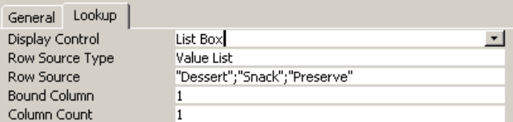

Description | Mark
list box and value list | ½
row source “Dessert”; “Snack”;”Preserves” | ½

  - In the table tblProducts create a drop down combo box for the field SupplierID based on a lookup to the table tblSupplier. Show all supplier details in the combo box.
Answer
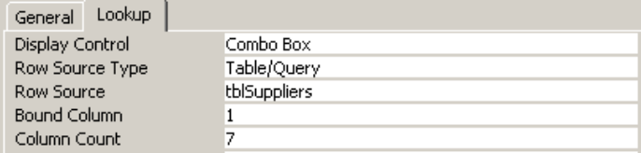

Description | Mark
Combo box and table/Query | ½
Row source: tblSuppliers | ½

  - Create a data entry form for the table tblProducts. Name the form frmProducts.
Answer
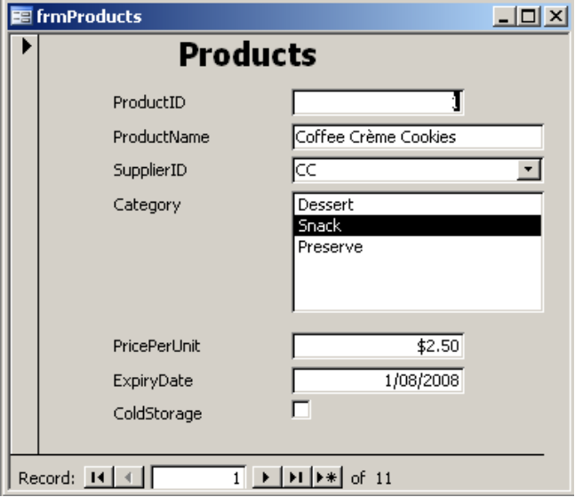

Description | Mark
All fields on form | ½
Form name frmProducts | ½

  - Add the following data using the form frmProducts:

ProductID | ProductName | SupplierID | Category | PricePerUnit | ExpiryDate | ColdStorage
10 | Apple Teacake | TD | Dessert | $3.90 | 06/06/09 | No
11 | Lemon Teacake | TD | Dessert | $4.15 | 06/06/09 | No

Description | Mark
Product 10 record completed | ½
Product 11 record completed | ½

- Create the following queries [7 marks]:

 | Query name | Find all products that are snacks
i. | qrySnacks
 | 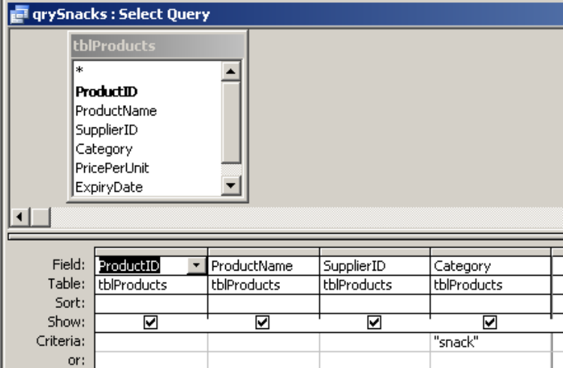

Description | Mark
tblProduct and fields | ½
“snack” criteria | ½

ii. | qry2to4 | cost between $2.00 and $4.00
Answer
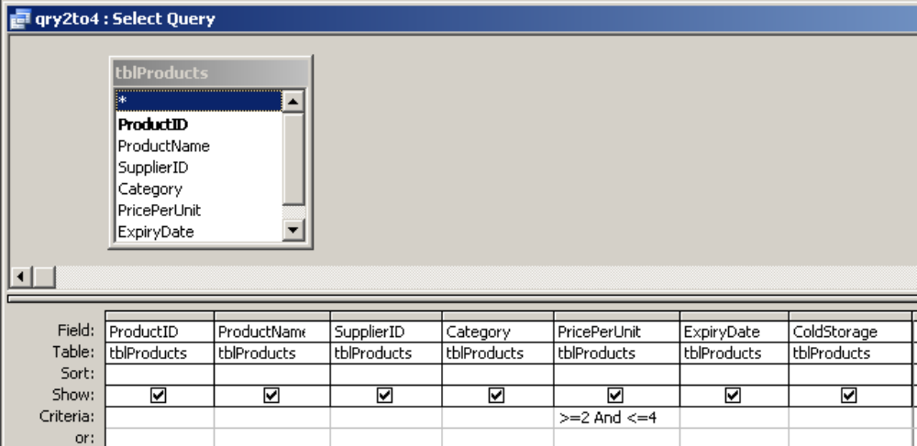

Description | Mark
Criteria: >=2 and <= 4 | 1
Alternate answer
Criteria: between 2 and 4

iii. | qryDessertSnack | are a dessert or are a snack
 | 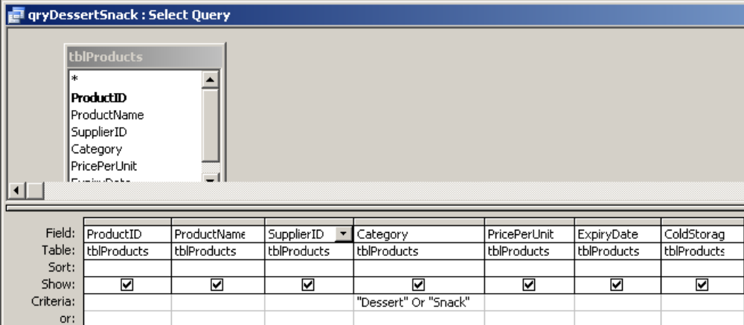

Description | Mark
Criteria: “Dessrt” or “Snack” | 1

iv. | qryPeaches | made with peaches
 | 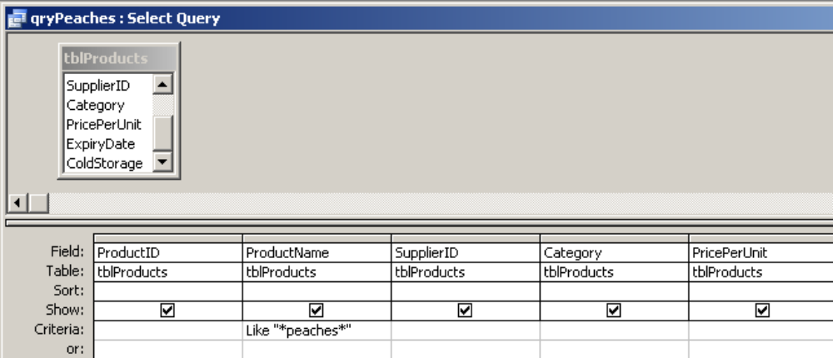

Description | Mark
Criteria: like “*peaches*” | 1

v. | qryColdOver5 | that require cold storage and cost more than $5.00
 | 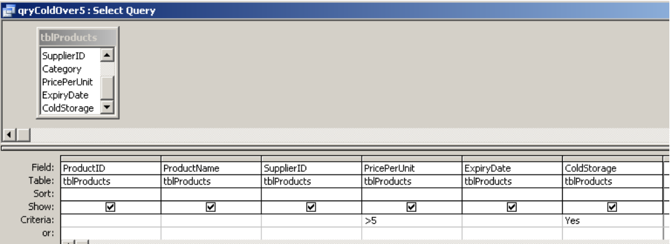

Description | Mark
Criteria: >5 | ½
Criteria: Yes | ½

vi. | qrySnackSuppliers | are snacks (display the Supplier name, the Product name and the price and sort the price from highest to lowest)
 | 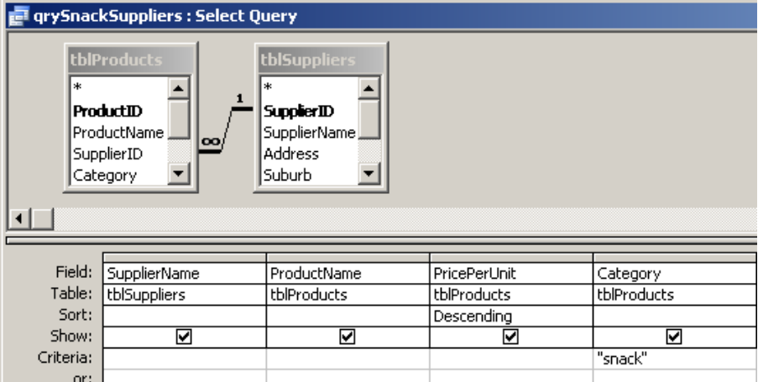

Description | Mark
tblProducts and tblSuppliers used | ½
correct fields | ½
sorted descending | ½
criteria: “snack” | ½

- (i) Create a tabular report called rptAllProducts that lists all the suppliers (by Supplier Name) with the products they supply in alphabetical order. Edit the report with an appropriate title.
Answer
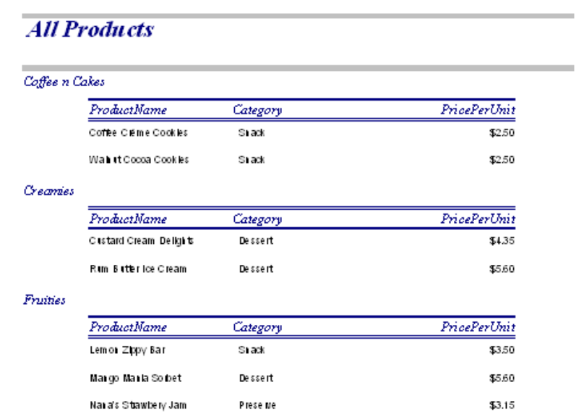

Description | Mark
Supplier grouping | ½
product name in alphabetical order | ½
title edited | ½
correct report name | ½

  - Create a report called rptAveragePrice based on tblProducts that groups products according to their category. The report should show the category, the product name and the price per unit. It should calculate the average price per unit in each grouping.

Answer
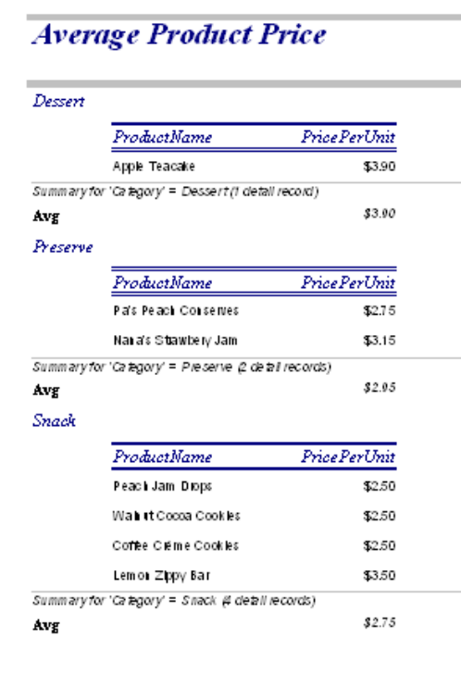

Description | Mark
Category grouping | ½
product and price fields | ½
average price | 1

PART B—PROGRAMMING

Question 24
The flow chart algorithm below is used to determine the total price of a given quantity of tickets, while applying discounts for customers when purchasing 10 to 15 tickets (10%) and for more than 15 tickets (15%).

Begin
Enter Quantity
Quantity < 10?

Quantity > 10
AND Quantity < 15?

Quantity > 15?

Discount = 0
SubTotal = Price – (Price * Discount)
Price = 10
TotalPrice = SubTotal * Quantity
Display “The total price of your tickets is $” TotalPrice
true
false
Display “Sorry no discount”

false
true
Discount = 0.1
Display “10% discount”

false
true
Discount = 0.15
Display “15% discount”

End
- Convert the flow chart algorithm above into a program module. Ensure all variable names are exactly as in the flow chart above. Save this version of your module as “Part A”.

Description | Mark
Variable declarations | 1
Quantity input | ½
Nested if then else statement | 3
Sub total and total price calculations | 1
Total price output | ½
Program compiles and runs | 1

Sample answer in Visual Basic

Dim Price as Integer
Dim Quantity As Integer
Dim Discount as Single
Dim SubTotal as Single
Dim TotalPrice As Single

Quantity = InputBox("Please type the number of tickets required.")

If Quantity < 10 Then
Discount = 0
MsgBox("Sorry no discount.")
Else
If (Quantity > 10) And (Quantity < 15) Then
Discount = 0.1
MsgBox("10% discount!")
Else
If Quantity > 15 Then
Discount = 0.15
MsgBox("15% discount!")
End If
End If
End If

Price = 10
SubTotal = Price - (Price * Discount)
TotalPrice = SubTotal * Quantity

Msgbox("The total of your tickets is $" & TotalPrice)

- Modify this module code to ensure that only positive values will be accepted for Quantity.

Description | Mark
Do | ½
Quantity = InputBox("Please type the number of tickets required.")  Loop Until Quantity > 0 | 1
Or  Quantity = InputBox("Please type the number of tickets required.") | ½
Do While Quantity <= 0 | ½
MsgBox ("Number of tickets must be greater than zero")  Quantity = InputBox("Please type the number of tickets required.") | ½
Loop

- Test your module, by using appropriate test data, to determine specific errors in the code by completing the table below.

Correct Results (calculated) |  |  | Program Test Results
Tickets | Discount | Total Price | Tickets | Discount | Total Price
0 | 0 | $0 | 0 | 0 | $0
1 | 0 | $10 | 1 | 0 | $10
9 | 0 | $90 | 9 | 0 | $90
10 | 10 | $90 | 10 | not shown | $100
11 | 10 | $99 | 11 | 10 | $99
14 | 10 | $126 | 14 | 10 | $126
15 | 10 | $135 | 15 | Not shown | $150
16 | 15 | $136 | 16 | 15 | $136

Description | Mark
Total Price calcuations | ½
test data for Quantity including:  Quantity < 10 | ½
Quantity = 10 | 1
Quantity between 10 and 15 | ½
Quantity = 15 | 1
Quantity >15 | ½

- Find any error(s) which stop the module functioning correctly and list them below. Implement the corrections needed to your module.

Description | Mark
Written explanation  If Quantity > 10 And Quantity < 15 Then, should include “=” sign to include  the values of 10 and 15 in the selection. | 1 ½
Changes implemented in the program  If Quantity >= 10 And Quantity <= 15 Then | 1 ½

- List below, any other corrections or enhancements which would be considered as good programming practice and implement your suggestions to your module.
Selections from the following up to 5 marks

Description | Mark
Price variable should be declared and used as a constant. | 2
Correct indenting and white spacing should be used. | 1
Comments should be included | 2

Other items could include
A CASE statement used in place of the If -Then.

- Modify the module to include a discount of 20% for ticket sales of 20 or more. Save this version of your module as “Part E”.

If Then Solution

If (Quantity > 15) and (Quantity <20) Then
Discount = 0.15
MsgBox("15% discount!")
Else
Discount = 0.2
MsgBox("20% discount!")

End If
Either:
Description | Mark
(Quantity > 15) and (Quantity <20) | 1
Else  Discount = 0.2  MsgBox("20% discount!") | 2

CASE Solution
Or:
Description | Mark
Select Case Quantity  Case 0 To 9  Discount = 0  MsgBox ("Sorry no discount.")  Case 10 To 15  Discount = 0.1  MsgBox ("10% discount!")  Case 16 To 19 | 1
Discount = 0.15  MsgBox ("15% discount!")  Case Is > 19 | 2
Discount = 0.2
MsgBox ("20% discount!")
End Select

Computer Science 2A / 2B Examination—Combined Written and Practical

 |  |  | Response—50 marks  Case Study—Music Store |  | Practical Exam—50
Components  (15) | (A = 8)  (B =7) | Hardware | Levels of storage (A)—3  Encryption (B)—1  Networking (B)—2 | Topology network (B)—2  Hardware (A)—2
Components  (15) | (A = 8)  (B =7) | Software | File compression (A)—1  Virus (B)—2 | Preventative maintenance & backups (A)—2
Design, Develop, management  (15) | (A = 7)  (B = 8) | Systems | System analyst (A)—1  Feasibility study (A)—1  System implementation (A)—2 | Data Dictionary (B)—4
Design, Develop, management  (15) | (A = 7)  (B = 8) | Ethics & law | shareware/freeware (A)—1  Network security/internet (B)—2 | Database privacy and on selling of data (A)—2  (B)—2
Tools  (70) | (A = 35) | Data Rep | Number systems—2
Tools  (70) | (A = 35) | Sys Dev Tools | Flowcharts constructs—2  Trace table—2 | DFD—4 | Programming—25
Tools  (70) | (B = 35) | Data Rep | Normalisation—1  DBMS Theory—4
Tools  (70) | (B = 35) | Sys Dev Tools | Network—3  ERD—2 |  | Database—25
TOTAL | (A = 50)  (B = 50) |  | 50 |  | 50
0000.doc

